**PROJECT REPORT**

711120104701 – Marshal M G

711120104702 – Alice Gracy A

711120104089 – Viknesh A R

711120104088 – Vijay M

1. Introduction:

1.1.Overview:

Building a website using Canva is a user-friendly and creative process that leverages Canva's design tools and templates to create a visually appealing and functional website. Canva, primarily known for its graphic design capabilities, now offers a feature called Canva Websites, which simplifies website creation for users without extensive coding or design skills. Users can choose from a variety of professionally designed templates, customize them with their own content, images, and branding elements, and publish their website with ease. Canva Websites provides a convenient drag-and-drop Interface, making it accessible to beginners and small businesses looking to establish an online presence quickly and affordably.

1.2.Purpose:

Car websites serve as valuable sources of information and support, assisting potential buyers with research, offering details about vehicles, promoting car models and deals, facilitating purchases, providing reviews and ratings, and serving as hubs for automotive enthusiasts and communities. Car websites play a crucial role in the automotive industry by serving as comprehensive online platforms that offer a wide range of valuable services. These websites are invaluable to potential car buyers, as they provide detailed information on various car models, including specifications, features, pricing, and performance.

1. Problem Definition and Design Thinking:

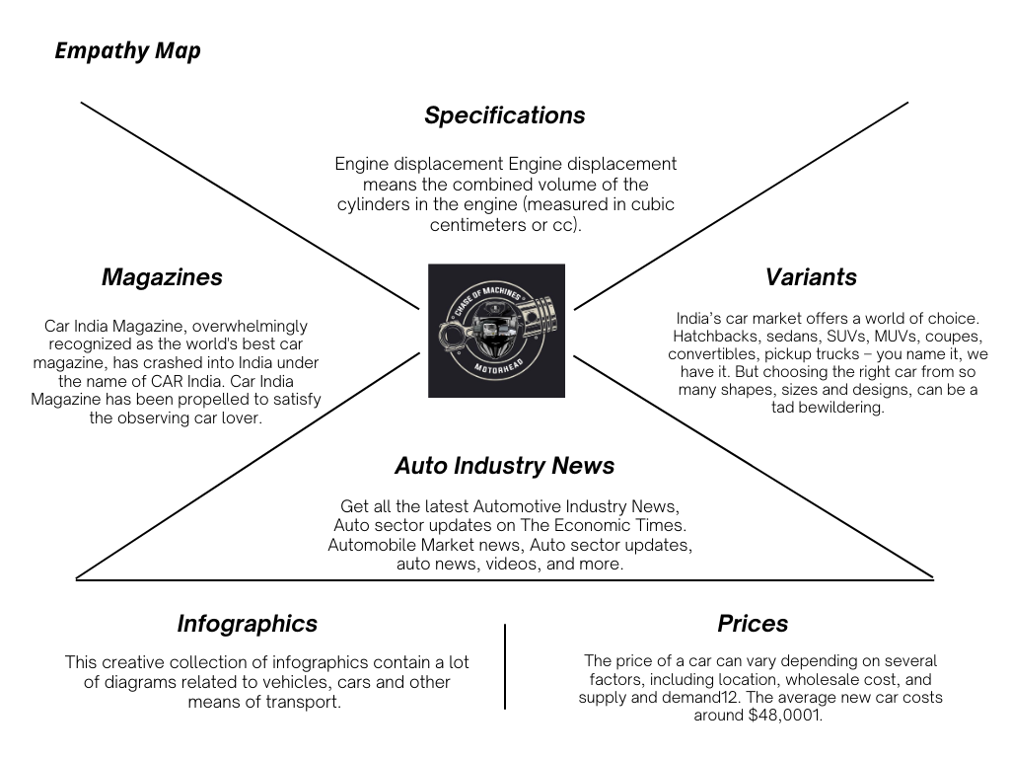 2.1.Empathy Map:

2.2.Ideation and Brainstorming:

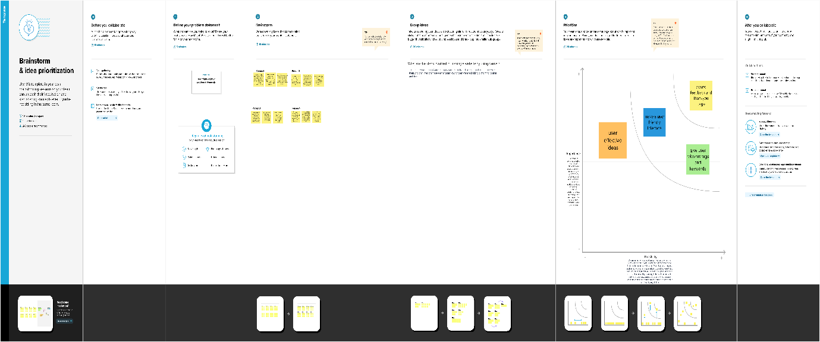

2.3.Result:

Website Link : <https://chaseofmachines.my.canva.site/>



